Marketing thrives on attention, and sometimes, a hint of scandal can be a tempting attention grabber. Imagine a clothing brand releasing a provocative ad campaign that sparks outrage online, only to reveal it was all an elaborate setup to promote their new line of "rebellious" clothing. This controversial approach can generate a buzz, propel the brand to the forefront of social media conversations, and leave a lasting impression – for better or worse.

The potential rewards of scandal marketing are undeniable. Free publicity, increased brand awareness, and a surge in website traffic can be tempting lures. But the risks are equally significant. Public outrage can spiral out of control, damaging brand reputation and leading to boycotts. The line between edgy and offensive can be razor-thin, and a misstep can have devastating consequences. Imagine a beauty brand launching a campaign with undertones of racial bias, facing a social media firestorm and a plummet in sales.

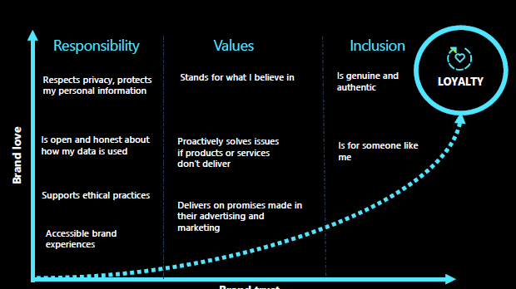

The key to successful scandal marketing lies in a delicate balance. The controversy must be carefully crafted, with a clear purpose and message. A healthy dose of self-awareness is essential – is the brand prepared for the potential backlash? And most importantly, is the scandal actually relevant to the product or service being advertised? Without a clear connection, the controversy becomes a hollow tactic, alienating consumers and damaging brand trust. So, while scandal marketing can be a tempting shortcut to attention, it's a path fraught with danger. Marketers who choose this route must tread carefully, ensuring the controversy sparks conversation, not outrage.